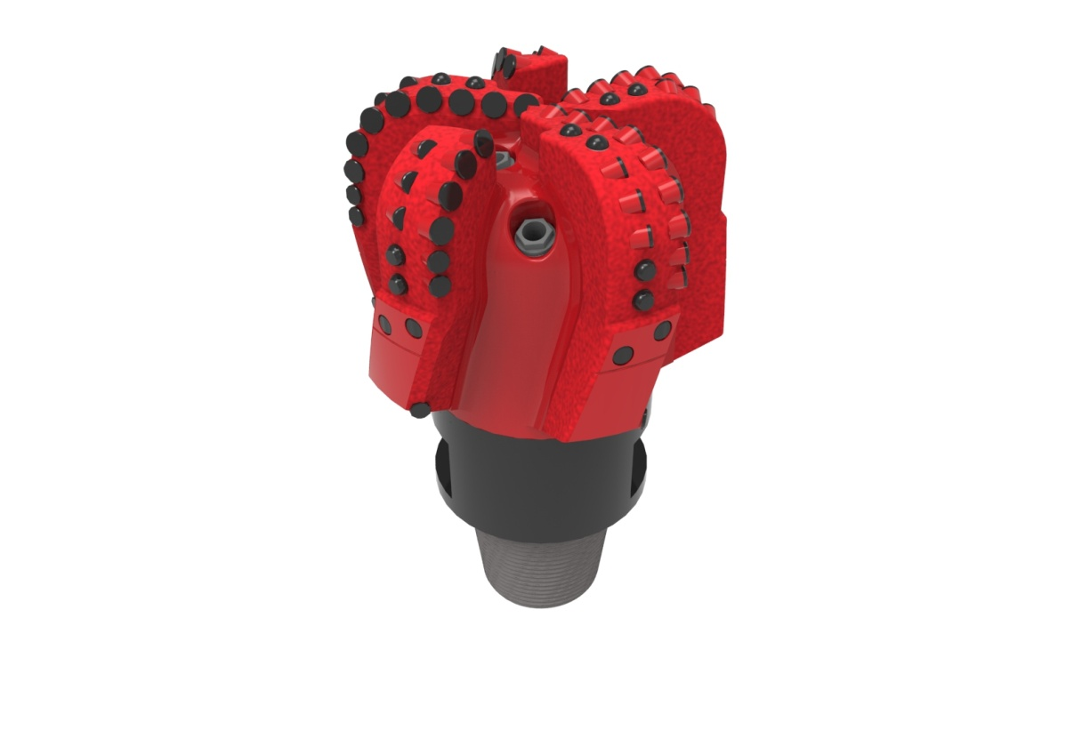
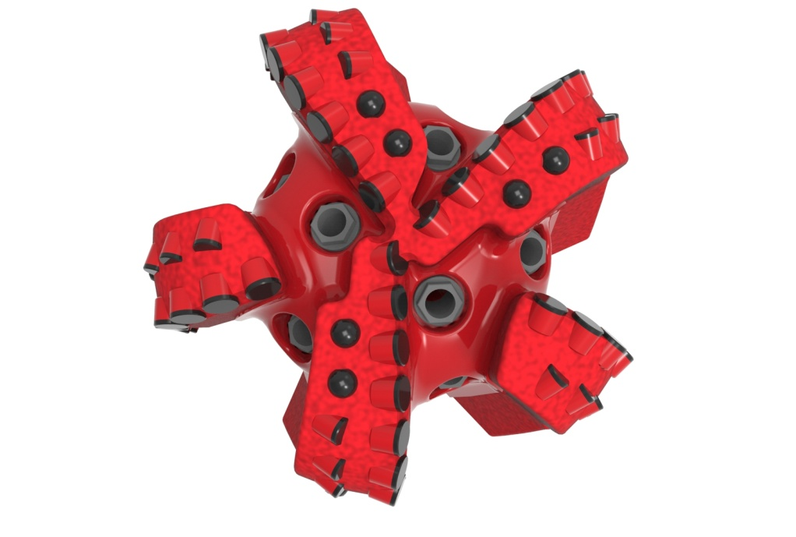

Drill Bit Specifications:
Cutter Size (Primary, Sec) | 5/8”,1/2”
Cutter Count (Total, Gage, Back Ream) | 61,10,5
Blade Count | 5
Gage Length (Inches) | 3.00
Nozzle Count (Primary, Sec.) | 8
Nozzle Series (Primary, Sec.) | 60
JSA (Sq. Inches) | 26.58
Max. TFA (Sq. Inches) | 2.97
Operating Parameters:
Max. Weight on Bit (1,000 Lbs.) | 60
Make-up Torque (ft/lbs) | 17,399
Nominal Dimensions:
Overall Length (Inches) | 15.92
Make Up Length (Inches) | 11.856
Bit Breaker | SKB-21010
Connection | Ø4-1/2" API Reg.
Approx. Weight (Lbs.) | 140

Standard Features:

- Premium grade cutters maximize ROP and Life
- Large open face volume assists cuttings removal
- Eight nozzles optimize blade cleaning and cuttings removal
- Selectively positioned bullets for smooth drilling
- PDC inserts for increased gage protection
- 1" full gage, 2" tapered gage at 1°

516-XR8(K)(BR) Nomenclature Explained:

• | 5 | = | Number of Blades
• | 16 | = | Primary Cutter Size (16mm)
• | XR+ | = | Backup Cutters
• | 8 | = | Number of Nozzles
• | K | = | Bullets
• | BR+ | = | Back Reaming Cutters


